Chapter 4 - The Economic Relations of the Colonies

Mercantilism (1500-1800) primary goal was to:
achieve power and wealth for the state
achieve political and economic unity
keeping artisans in the home country
They tried to achieve this by:
have colonies export raw materials and import manufactured products from the mother country
establish an excess of exports over imports
strictly regulating economic life through the national military power
the use of taxes(ie the Navigation Acts) and subsidies to control trade

Under the British Navigation Acts (first passed in 1651 but started to be really enforced in 1696), enumerated goods were a list of colonial exports that had to be shipped through British middlemen.
It was required all colonial trade to be carried on English vessels.
It allowed colonial trade on British ships commanded by foreign captains.
Exports had to be shipped through British middlemen.

During the colonial period, goods that could only be exported legally to Britain were known as, “enumerated goods” and included:
- tobacco.
- sugar.
- indigo.
- cotton.

During the English civil war in the 1640s, the Dutch made great inroads into the carrying trade.

Imports:
New England colonies, the Middle colonies, the upper Southern colonies, and the lower Southern colonies obtained most of their imported goods from the United Kingdom
In terms of imports to the colonies, the West Indies and the United Kingdom were the top two trading partners.

Exports:
New England’s exports went primarily to the West Indies.
The Southern Colonies’ exports went primarily to the United Kingdom.
The Middle Colonies’ exports went primarily to the West Indies
Colonial coastal commerce comprised about 1/3 of the volume of total overseas trade.
Shuttle routes for colonial trade
- lowered labor costs.
- reduced delays and costly extensions of port times.
- were more common than triangular trade patterns.
- allowed captains to negotiate with a small number of familiar trading partners.
Percentage Distribution of Colonial Trade by Region
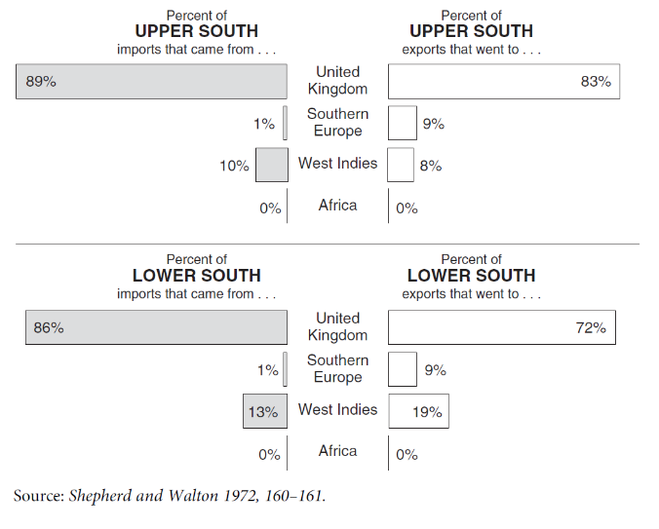
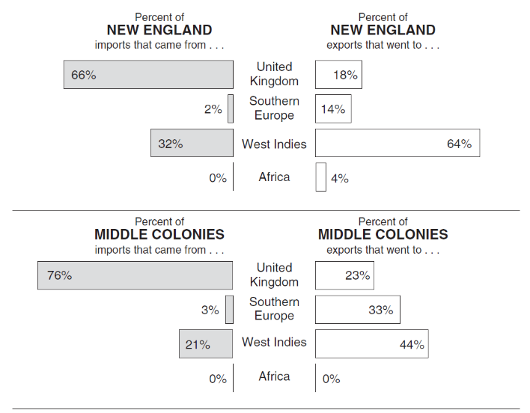
In 1768-72, the top ten commodity exports of the thirteen colonies were:
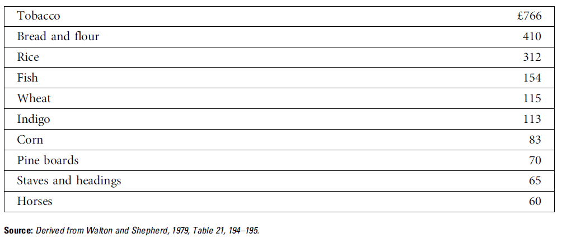

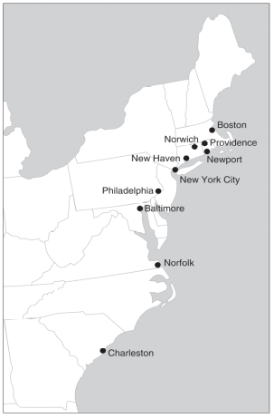

In 1776, was the most populated colonial cities were – all were port towns:
Philadelphia = 40,000
New York = 25,000
Boston = 16,000
Charleston = 12,000
Newport = 11,000

Money:
Early forms of colonial money included:
- wampum.
- tobacco.
- furs and hides.
- musket balls.
- Commodity money
- Problem with using commodity money in the US colonies prior to 1700 included: 1) commodity spoilage rates were high, 2) controlling the quality of payments made with commodities, 3) inconvenience and 4) high storage costs of commodities.
- Coins issued by the Spanish mint were the most common form of specie used in the colonies.
- Types of money used by colonists included all of the following 1) gold and silver coins, 2) bills of exchange, and 3)bills of credit.
- Bills of exchange and bills of credit typically had a market value that was less than their face value.
- The Currency Act of 1751 was passed in response to English merchants’ concerns about the fluctuating value of colonial money.
- The Currency Act of 1764 was supported by British merchants.
- A notable and unique feature of the colonial monetary system was Colonial America was the first region in the world to permanently use paper money –China invented paper money and had used it long ago, but nowhere had used paper money after 1500.
- The Middle colonies had the largest commodity trade deficit.
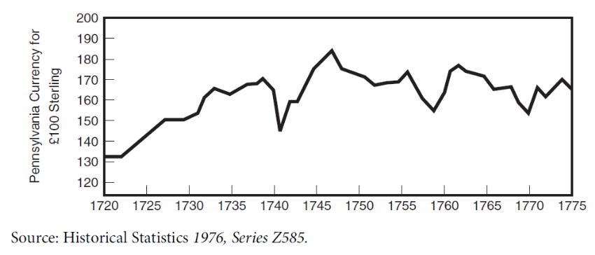
The annual colonial trade deficit (which equaled 20,000-40,000 pounds sterling in 1768-1772) was mostly financed by short-term credit from England.
The colonies as a whole had a significant commodity trade deficit with England. In order to finance this deficit the colonies relied on all of the following sources of income1) a commodity trade surplus with Southern Europe, 2) the sale of colonial shipping services, and 3) British government spending in the colonies.

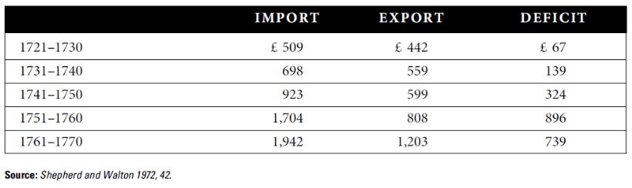

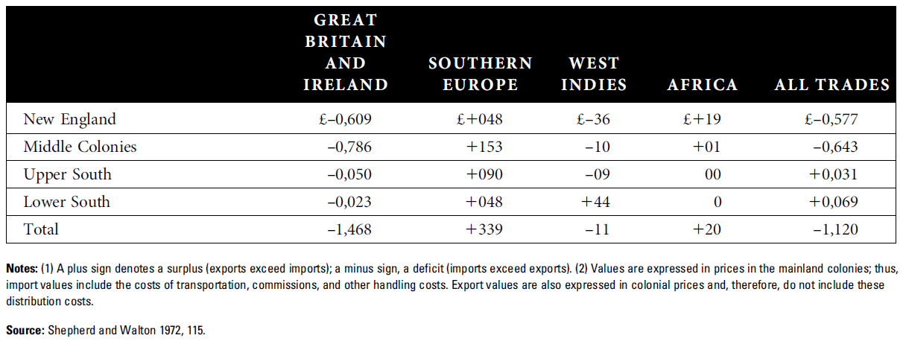

Capital formation in the colonies was mostly due to savings and investments from the colonists themselves.

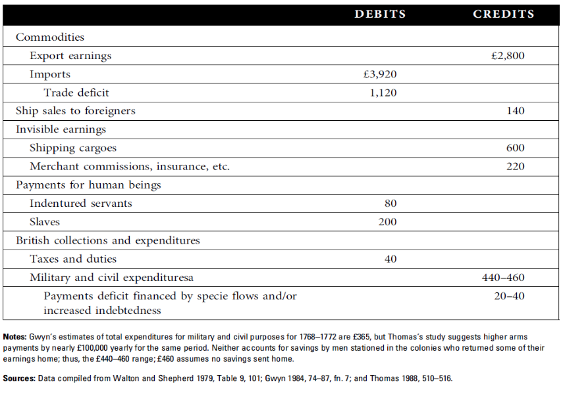
The most important source of foreign exchange earnings to offset the colonial deficit with England was the sale of colonial shipping services.

